5G/6G Communication Systems- ECA5601 (LAB)
Student Name: A.SAI KIRAN
Reg no: 192312672L
Experiment 2: - Implementing TDMA Slot Allocation in GSM.
AIM: To implement TDMA (Time Division Multiple Access) slot allocation in GSM using MATLAB and analyse system performance in terms of time slot duration, frame utilization, and number of allocated slots.
Objective:
1. To calculate the Time Slot Duration in a GSM TDMA frame by dividing the total frame
time into equal time slots. This helps in understanding the time structure of GSM
communication.
2. To determine the Frame Utilization (%) based on the number of allocated time slots
compared to total available slots. This evaluates the efficiency of TDMA resource usage.
3. To compute the Number of Allocated Time Slots for multiple users in the GSM system.
This ensures proper scheduling and interference-free communication.
Procedure:
1. Define GSM frame parameters such as total frame duration and number of time slots.
2. Compute time slot duration by dividing frame duration by number of slots.
3. Assign time slots to multiple users based on availability.
4. Calculate frame utilization percentage using allocated slots vs total slots.
5. Determine total number of allocated slots for active users.
6. Plot time slot allocation and utilization using MATLAB graphs.
7. Display results in the command window for analysis..
Objective 1:
MATLAB Code:
clc; clear; close all;
FrameTime = 4.615; Slots = 8; SlotDuration = FrameTime/Slots; t = 0:SlotDuration:FrameTime; figure subplot(2,1,1) stem(t,ones(size(t)),'filled') title('TDMA Time Slot Structure') xlabel('Time (ms)') ylabel('Slot Level') grid on subplot(2,1,2) plot(t,ones(size(t)),'-o','LineWidth',1.5) title('Continuous View of Slot Allocation')

xlabel('Time (ms)') ylabel('Slot Presence') grid on

Output:
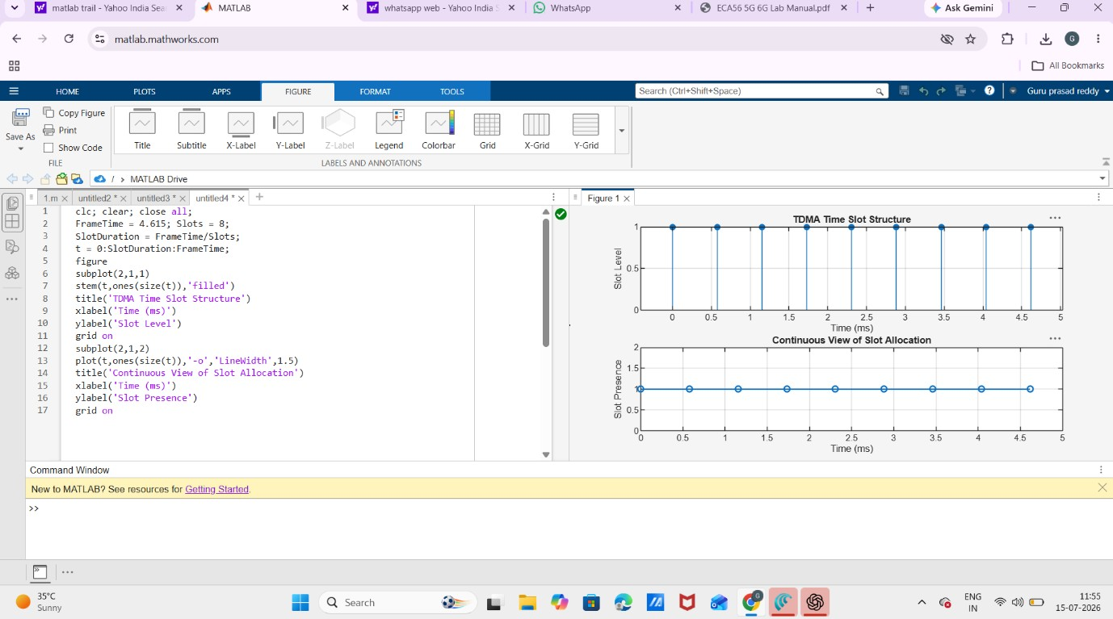
Objective 2:
MATLAB Code:
clc; clear; close all; TotalSlots = 8;
AllocatedSlots = 6;
FreeSlots = TotalSlots - AllocatedSlots; Utilization = (AllocatedSlots/TotalSlots)*100; disp('Frame Utilization (%)') disp(Utilization) figure
% Graph 1: Simple Line Plot (SAFE - no bar function) subplot(2,1,1) plot([1 2],[AllocatedSlots FreeSlots],'-o','LineWidth',2) title('GSM Frame Utilization (Allocated vs Free)') xlabel('Slot Type Index (1=Allocated, 2=Free)') ylabel('Number of Slots') grid on

% Graph 2: Pie Chart (SAFE) subplot(2,1,2) pie([AllocatedSlots FreeSlots]) title('Slot Distribution in GSM Frame') legend('Allocated','Free') Output:
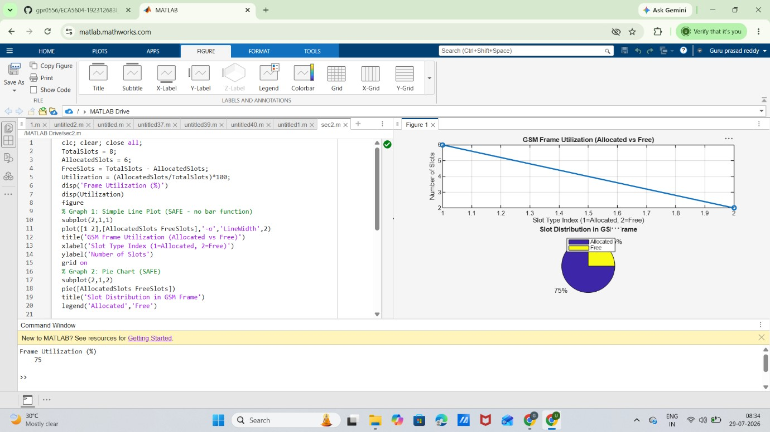
Objective 3:
MATLAB Code:
clc; clear; close all;
Users = 1:8; % Total users
TotalSlots = 5; % Available slots
Alloc = zeros(1,8); % Initialize allocation
Alloc(1:TotalSlots) = 1; % Assign slots to first users Blocked = 1 - Alloc; % Remaining users blocked disp('User Wise Slot Allocation') disp(table(Users',Alloc','VariableNames',{'User','Status(1=Allocated,0=Blocked)'})) figure
% Graph 1: Allocation per user subplot(2,1,1)

stem(Users,Alloc,'filled','LineWidth',2) title('TDMA Slot Allocation per User') xlabel('User Index') ylabel('Slot Status (1=Allocated, 0=Blocked)') ylim([-0.2 1.2]) grid on
% Graph 2: System view (safe alternative to bar) subplot(2,1,2) plot(Users,Alloc,'-o','LineWidth',2) hold on plot(Users,Blocked,'-s','LineWidth',2) title('TDMA Slot Utilization Analysis') xlabel('User Index') ylabel('Status') legend('Allocated','Blocked') grid on

Output:
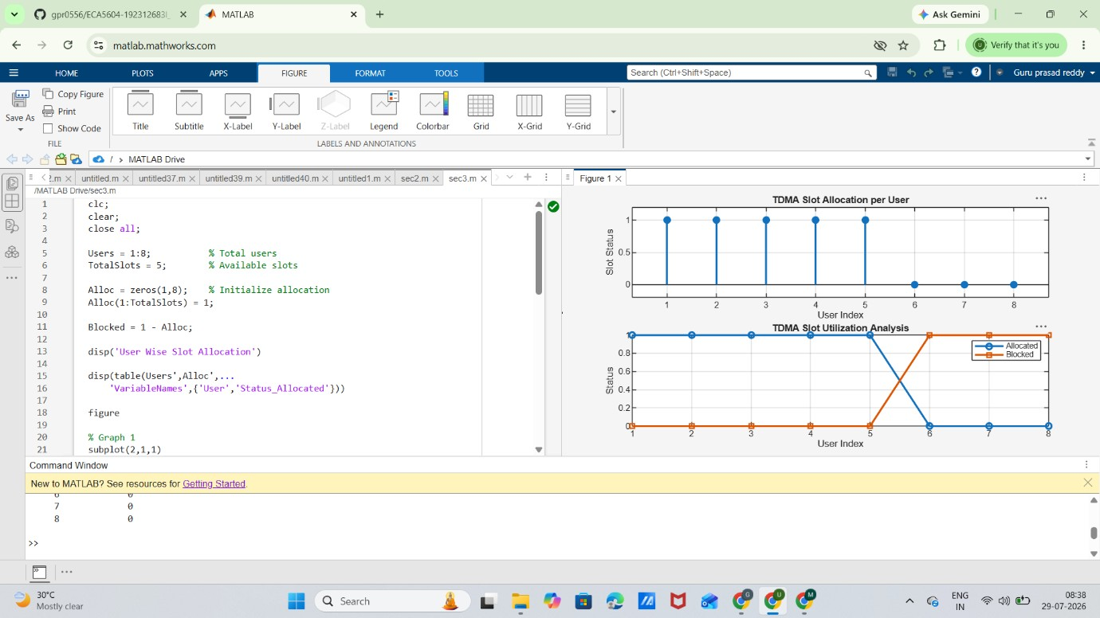

Result:
The TDMA slot allocation in a GSM system was successfully implemented using MATLAB. The time slot duration, frame utilization, and number of allocated time slots were calculated, demonstrating efficient and interference-free resource allocation among multiple users.

